Case # | Input | Expected Output | Actual Output
1 | no | Exit message | Displayed exit message
2 | 1234567890 | Error try again message | Displayed error message
3 | 123-456-7890 | No error message | No error message was displayed
4 | 217841234 | Error try again message | Displayed error message
5 | 21784-1234 | No error message | No error message was displayed
6 | 1 1 1, 2 2 2, 3 3 3 | Display matrix 1 | Displayed matrix 1
7 | 2 2 2, 3 3 3, 4 4 4 | Display matrix 2 | Display matrix 2
8 | A | 3 3 3, 5 5 5, 7 7 7 | Result, Transpose, Mean Values
9 | B | -1 -1 -1, -1 -1 -1, -1 -1 -1 | Result, Transpose, Mean Values
10 | C | 9 9 9, 18 18 18, 27 27 27 | Result, Transpose, Mean Values
11 | D | 3 3 3, 5 5 5, 7 7 7 | Result, Transpose, Mean Values
12 | E | Exit operation then exit message | Exited Operation, Exit message displayed


TC1:
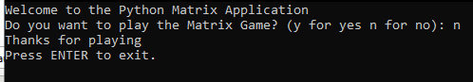

TC2:
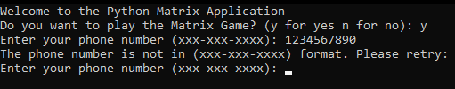

TC3:
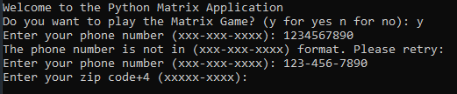

TC4:
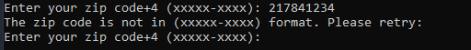

TC5:
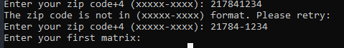

TC6:
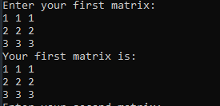

TC7:
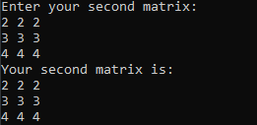

TC8:
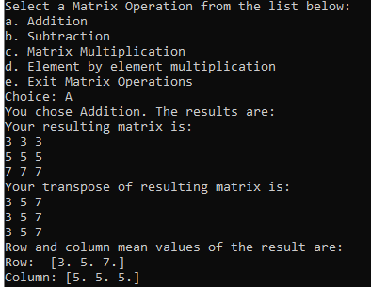

TC9:
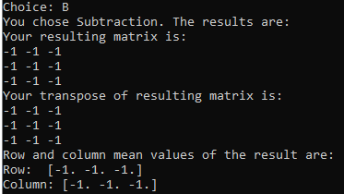

TC10:
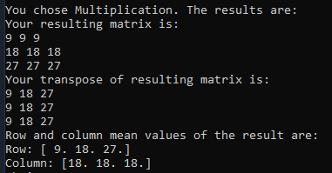

TC11:
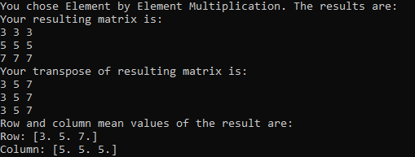

TC12:
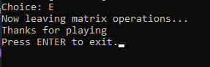

CRACK STATION REPORT

Password | Hash output | Did Crackstation work?
password01 | MD5: af88a0ae641589b908fa8b31f0fcf6e1  SHA-256: 4b8f353889d9a05d17946e26d014efe99407cba8bd9d0102d4aab10ce6229043  SHA-512: 746a5a2664633cb15829e80cc8d5dd7368b1d939756e7b069df9df482e2afc3c44029ec71ffbf7cc9916719d861b60fc34b5bd6a4f2cb0fe7747d99d5b219162 | Exact match for all
thisismypassword01 | MD5: 3b426f4fa44cb30878686de3dc4880dd  SHA-256: 6e7d94a32324e69be4b6d235a5f893c9feea1b772fa184bca53a9902d9a6c073  SHA-512: 4a1f027494355edf4e1f325b11531998171a9ccebd1575c8b90e8331b78915c7d85bcfc00e6978247fbc5c4ee36fc0123b8caddc4a3f942b5932d2651c26b5ac | Not found for all
Dogs4life! | MD5: 92ec9e2f0b5f4557158722a4e7e9f766  SHA-256: 15093f8058ffafd01ddd6ed4e318570b8d7068ba5c2163cb9883ca7a2a6b46f8  SHA-512: aa398a8153d46272401b3a877ee53251657f13912b3d9cb0cf046795ae00b358936a394e4df43bac0bb1994482a91c32e1401604a4e7994056c831f4d007fd40 | Not found for all
ILoveDogs4life! | MD5: 0d2e1f472e2cd28c45751b34109312ea  SHA-256: 8aa0b9ed7be0ee163a5097c630563d13ab32d69ec37821bbbccd01d7fc92f913  SHA-512: e6323bcd6a3423dd5ed2aee9aa40cf7ae0f7246fca70ef4d86e08a87da3ef90d925c1bfb9772fd26b7866788b24b9d3f713a138f4f9eaf36f1fc3932685d588b | Not found for all
LetsgoRavens | MD5: 2427be408b8fe101aa83e346c4365402  SHA-256: f73a9472eb3c15ab7f33e8cfd1c557c2f800e98ad42d9d7a44799b9528f65f6e  SHA-512: ff55794cbd843bf28dd33369c0ea81a2516842c5de902592d3ec8277213245e332b5de52edd32b3081e7e137886a2ca97bd4bca312070f6f3878eb1e251f4aaf | Not found for all
Ph8wRa3! | MD5: a811a5d149b0639f82a7414b020b16ae  SHA-256: 950f22b397399e370ed3b87a350a23751dcd6beffbb1381395e7e54979205903  SHA-512: a399bf83efa210f8a10d00b0c919d759badd81f6b3399ede50818bb7b583c7226d0b1baa22ab4aac86589884c71ba4d47e17548fa7cf979d6a79e66653d5891a | Not found for all
tiFrazo16dr@ | MD5: a4c3b2092ab1f178d38bc19f4612ba31  SHA-256: 2c6787c7fbe19aa244c7cf136299e45f665c5dabeb59f008dacf830cc8e9ada6  SHA-512: 6934bf6cc76bfc7d198f7d34950d48c34c0e02b02b8d1ac018f4324ed96ca1a0365ea4c9a21b12816eb618c49cb1cd0acf3963db08102beeb6291d189ac10d26 | Not found for all
-rI=wE31Ic*V | MD5: 3c9d866684e84ed4bd10d953a5b762f2  SHA-256: 92c930ade01d87adacb637195c97efe5f36ca27db3bfe168e1c641c01a5f82b8  SHA-512: e4f952118efc65ab9f18a05463f013a1ba1b469216b860f24aa7a2ceef714a874d48b449664324f4d1625e589177b1852379a33baa0951e631ae6623da507342 | Not found for all
GaBl4rlM_p#3 | MD5: 1de0bb51effcfdb1f801d9b8bd27b0fc  SHA-256: d251e2012018a47f6cdfe7034f7a3af03914e8219ea67bf72f6f51843cd65f30  SHA-512: 0d8aaaa81a59f889a7cb9e6c92e251b330157ea0b6e9326bc4e949d39fc9b16d6a54f4ead706b3914f838c3275ef1dfb82998afb40255b9ae98058039e8dd94e | Not found for all
jIt02+pe3o-l | MD5: 416e865d5756e7e5dce0b3e73f574632  SHA-256: f489819585db15399a6f53ea631c5a0d6605377f4fcb98818eec3010ccc6c1cc  SHA-512: 6d63bf9090632d78037741b3f656dd6acc5ac70243af6c853d1ac970897861e3ef885865b38e3d8d2af19c7750d972da76fcd118612aab9a406856d43e3cf337 | Not found for all
Ti_hUCR41+C2 | MD5: c9c35022143525d7dd330f2ce61379a4  SHA-256: 839b237c36648f66bb452e18da1ecd4c9d07bd953a55d8cd5492176e20086c86  SHA-512: 8425b304b2c38a3ed72b5cdb0b407a0ffe30aef838c6f34247b000471fa697038ddac5c98d6ec51a784c1c1a5faa3d05e200741caf93a159f9d629c114b2777d | Not found for all
f#dR#fl71pre | MD5: 3ecf9aa7da110fa1febe6bb789fd3fd3  SHA-256: 297d7accec16b0c8fec14a5f857cc5c696de045ce04985c142cdd30bee2d768a  SHA-512: 66bdeecdd1292922402bd4392b8754c02833e537a1183f2cbf8a1064e161320b1180d226665309f59c51fb712ae1176e947eb7f36b9c29e360924f33054f67b6 | Not found for all
p-?41hiTrIwR | MD5: c19372ed3ea900b0eee0e47e8d388653  SHA-256: 79d9fbb8abf773f48686a472ca06519b2b464343a48ae8f07499ad29a03f6c19  SHA-512: 54d4a43b9a3ab43e85a7ea3a13a764be6f5b26daba385a5c44bf27a2abb8e2db85301fca4f71aae83ed940ce64ef6c2182e84cdc3592f117caf2fa217007cb40 | Not found for all
nlfaDRo4&azIg#S=dr | MD5: 8b63828cc54e5e59ae1f475a5ad0ccf0  SHA-256: f87a7291d930fe752d3242d7b2fc83ef3a1d51ef508c0f6df3802db7a23970d4  SHA-512: ae14eb4e870865fc48272e780fb7a1f59c77c3a98a13e0ff218a2e27081de89baf9e5089e1547c38909532ea6daa3390a9f6742a8cb03b893528795a0f49147e | Not found for all
2o36*ipRinl*i1us-l | MD5: de286e39456d5c251cda1462de6db498  SHA-256: ff763b6182a311ae953c5ce1925b4f5e79b8580a21fa2f80e17564c6c5028a5f  SHA-512: 8b644b951a8c32a7353e75a23e38f31270a1b59424c1952f4011f96b3b42b0bc29e58ea90a719253b4d9dae01036ccd55b674a051b1a9a8cf560305282fdc9eb | Not found for all
dumoxltrisweglprln | MD5: 00c1967796c196fc09151fb64f7058bf  SHA-256: 0e8e081e70ec756583ad35d984572745e2c3ad12a814b9d48640d1542688469d  SHA-512: 07520bdb7e5f3dc6411b6e5e0ff4cfb19b9d472fd86df6e88c498fd8a865e3930cdac16a2f92c0d54813cb578f015703be4b70747bfaaae121e2745530a6c7d5 | Not found for all
vlcogist | MD5: a851a4611d1951e5888a285abe933232  SHA-256: a61a9ff40e59b782c5c895849ba0a0d6ed35f529aee2bc4bdb9f1522d2579f54  SHA-512: f47e082024720175a13525cf6b242d171709af831eb2fae893fa1ad8c77cb6064f5e045d19695e59ef66a9ddc365c8195eed82644b59ae8f805be683a5d8cfa9 | Not found for all
phitroprltrablkiki | MD5: 6687a3c654d56620e781657574efbe5c  SHA-256: c0abbb5db719e75ea7d54a9cf7e96860003e3c382edb4f3fe514db323b776891  SHA-512: 115bf2787bbd239c5b4d6b9f7294c11ec4b1193cb5dbda98e6c81021d68e5b454c5eaf55440d8fdb9f942cbe84bab940b714e449ccaae528ce08ca80352e57f6 | Not found for all
yoyeni1racr6vlk9ph | MD5: 1c5207c8882cf5d99449b9e4d4442286  SHA-256: ed0940113a65adcc2c6719aa23c455f29e7549177b21482dcd8cce7b64ebdee9  SHA-512: a654bcea082b6fae26619c759534a633b1bd38f4e1461450bd70d915d9c8b07eff6007884599f8471049881727e508dced635b6f73bf35b478d196c174fe256b | Not found for all

